

SCHOOL OF PSYCHOLOGY

118 College Drive #5025 | Hattiesburg, MS 39406-0001

Phone: 601.266.5411 | Fax: 601.266.5580 | mark.huff@usm.edu | www.usm.edu

March 4, 2021

The Graduate School

McCain Library

The University of Southern Mississippi

118 College Drive, #5024

Hattiesburg, MS 39406

To whom it may concern:

I am writing in support of Nicholas Maxwell’s application for the Graduate Competitive Travel Award. This award will provide Nick with travel support to present his work at a major conference and will greatly help with his educational development and growth as a graduate student.

The award will be utilized towards Nick’s attendance to the 62nd annual meeting of the Psychonomic Society which is being held this year in San Diego, CA on November 18th-21st. The Psychonomic conference is the major international conference for Cognitive Psychology and Judgment and Decision Making and currently has over 5,000 members and often attracts more than 2,500 researchers, students, and professionals who are engaged in the above areas ([www.psychonomic.org](http://www.psychonomic.org)). The Psychonomic conference is the flagship meeting for researchers in cognition and Nick has an excellent opportunity to join them in November. It is critically important for his educational development to be provided with additional exposure to the cutting-edge research and to build collaborative relationships that can assist him in networking with scholars at other institutions.

Nick is fully eligible for this award: He is currently a graduate student who is enrolled in our PhD program in Brain & Behavior and is in good academic standing. He began his studies in Fall 2018 and received this award previously 2 years ago. Nick has not yet submitted an abstract to the conference as the submission window is not yet open, but he has a completed project with data that are of appropriate quality for an international conference. The conference abstracts are typically accepted through the end of May and decisions made by September. I will be listed as a co-author on his submission and can confirm that he will attend this conference upon acceptance.

I will also note that the School of Psychology is prepared to provide matching funds for the conference up to $250 as required by the application.

If you have any questions about Nick’s conference submission or his application, please do not hesitate to contact me following my contact information below.

Sincerely,

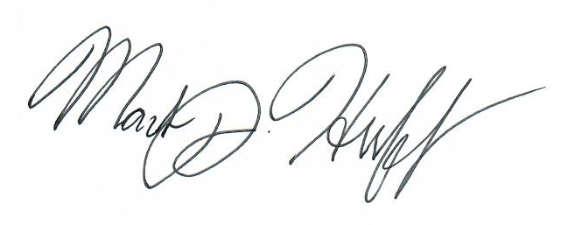

Mark J. Huff, PhD

Assistant Professor, Psychology

The University of Southern Mississippi

601.266.5411

mark.huff@usm.edu

I am planning to present my research at the 62nd meeting of the Psychonomic Society, which will be held November 18th through the 21st in San Diego, CA. The Psychonomic Society is one of the largest international societies of cognitive psychologists, with approximately 5000 members across the world, including some of the most distinguished researchers in the field. The primary goal of the society is to encourage the growth of cognitive psychology as a science through the publication of scholarly journals and annual meetings. These meetings focus on new and emerging areas of study, the use of novel research techniques, and have an emphasis on fostering collaboration and discussion amongst cognitive psychologists.

Participating in this conference is important to my professional development as an academic for two reasons. First, this conference provides me with the opportunity to present my research on an international scale. This is valuable experience, as it allows me to receive feedback on my work from experts in the field, share my work to a diverse audience, and gives me exposure to new and emerging trends within the field of cognitive science. Second, this conference provides me with an excellent opportunity to make connections with other researchers in the field, as I will have the opportunity to network with experts, and connect with other graduate students conducting related research, which opens up the possibility of collaboration on future products.

**Abstract to be Submitted:**

**Title:** Perceptually Distinctive Features of Study Words Do Not Inflate Judgements of Learning: Evidence from Font Size, Highlights, and Sans Forgetica Font Type

**Authors:** Nicholas P. Maxwell, Trevor Perry, & Mark J. Huff

The judgment of learning task (JOL) is often used to assess monitoring at encoding. Previous research has shown that JOL accuracy is sensitive to perceptual cues and can induce metacognitive illusions. For example, the *font-size effect* (Rhodes & Castel, 2008) occurs when participants inflate JOLs for pairs presented in large font vs small font. The present study provides an additional test of the font-size effect and tests whether other perceptual manipulations affect the correspondence between JOLs and recall. Experiment 1 was designed to replicate the font-size effect and test whether the effect extended to highlighting using a set of related and unrelated word pairs. Next, Experiment 2 provided an additional test of these effects on JOLs using only unrelated pairs. Finally, Experiment 3 tested whether Sans Forgetica—a perceptually distinctive font designed to improve memory—would result in inflated JOLs. Overall, the perceptually distinctive conditions did not result in an overestimation of later recall relative to non-distinctive conditions, and Sans Forgetica font in Experiment 3 yielded a memory cost (though no effect on JOLs). Collectively, perceptually distinctive study items do not appear to inflate JOLs at study.

**Estimated Budget:**

I am expecting a round trip flight from New Orleans to San Diego to cost approximately $375.

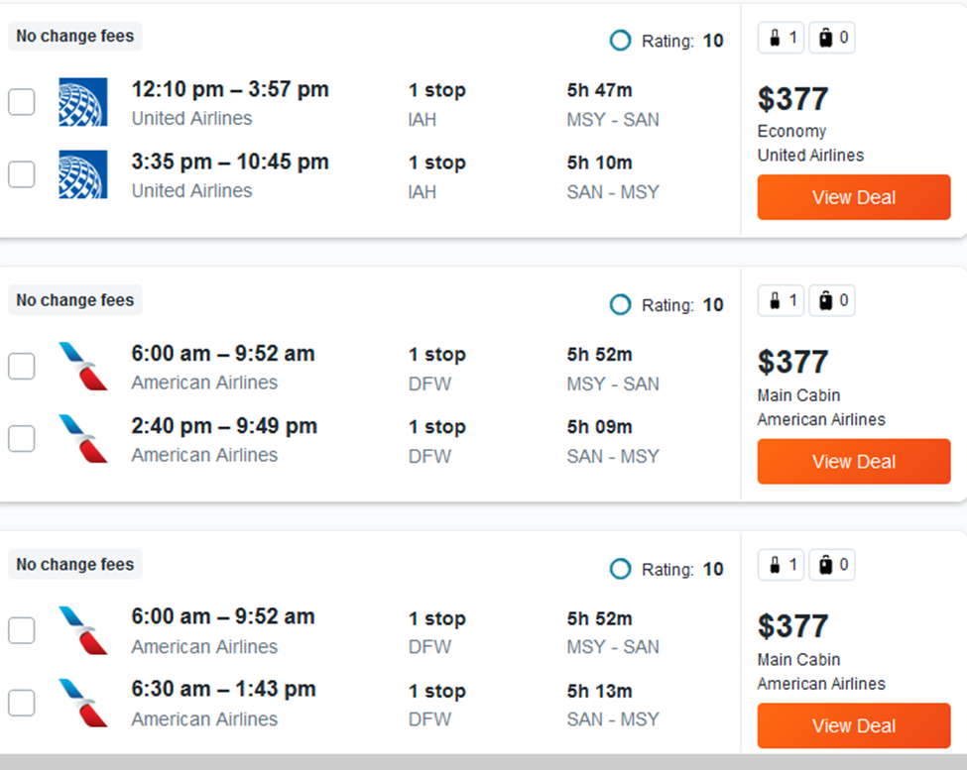

Because the conference is not until November, information about any conference sponsored hotels has not yet been made available. However, a search of nearby listings shows that I should expect to spend at least $125 a night on hotel accommodations. Since I will be staying for at least three nights, I should expect to spend at least $375 on lodging.

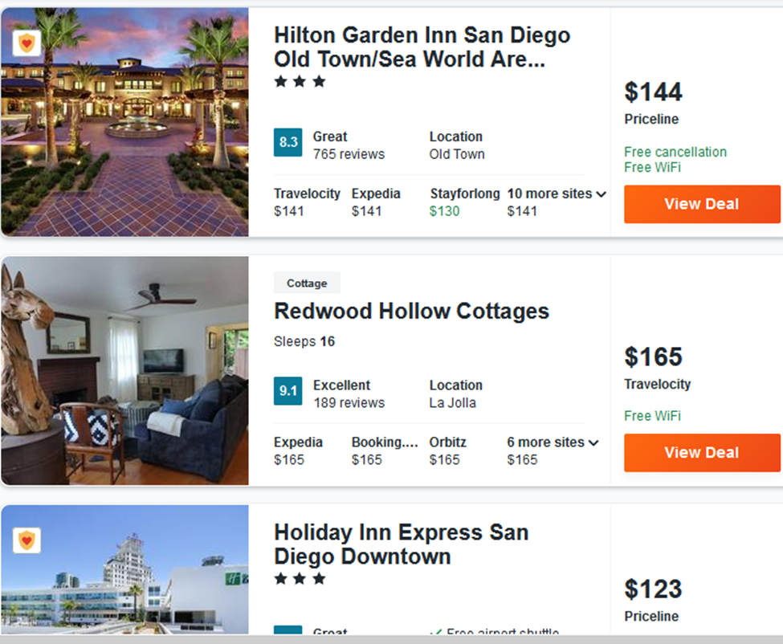

Thus, I am anticipating that the cost of this trip will be approximately $750 for transportation and lodging.